Chapter 4.
Continuous Random Variables and Probability Distributions
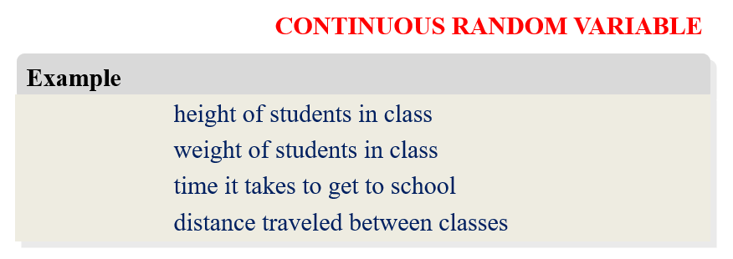
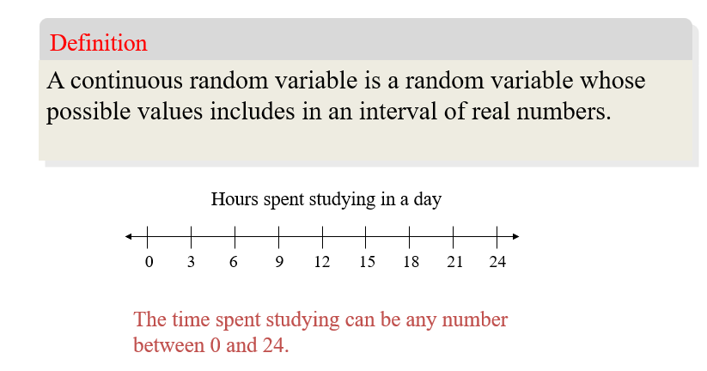

Discrete random variable | Continuous random variable
Probability mass function: $f\left(a\right)=P(X=a)$, and it has the following properties:  $$f\left(x\right)≥0$$  $$\sum_{i}{f(x_{i})}=1$$ | Probability density function (PDF)  $$f\left(x\right)≥0, ∀x$$  $$\int_{-∞}^{∞}{f\left(x\right)dx}=1$$  $$P\left(a≤X≤b\right)=\int_{a}^{b}{f\left(x\right)dx}$$
Cummulative probability distribution:  $$F\left(a\right)=P(X≤a)$$ | Cummulative probability distribution: $F\left(a\right)=P(X≤a)$  $$F\left(x\right)=P\left(X≤x\right)=\int_{-∞}^{x}{f\left(t\right)dt}$$
Mean $μ=E\left(X\right)$  $$=\sum_{i}{x_{i}f(x_{i})}$$ | Mean  $$μ=E\left(X\right)=\int_{-∞}^{∞}{xf\left(x\right)dx}$$
Variance $σ^{2}=E\left({\left(X-μ\right)}^{2}\right)$  $$=\sum_{i}{{\left(x_{i}-μ\right)}^{2}f(x_{i})}$$  or  $σ^{2}=E\left(X^{2}\right)-μ^{2}=\sum_{i}{x_{i}^{2}f\left(x_{i}\right)}-μ^{2}$ | Variance  $$σ^{2}=E\left({\left(X-μ\right)}^{2}\right)$$  $$=\int_{-∞}^{∞}{{\left(x-μ\right)}^{2}f\left(x\right)dx}$$  $$=\int_{-∞}^{∞}{x^{2}f\left(x\right)dx}-μ^{2}$$

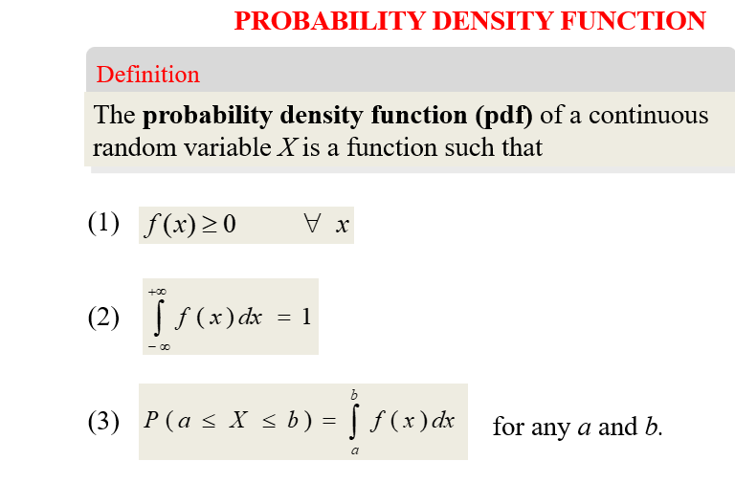
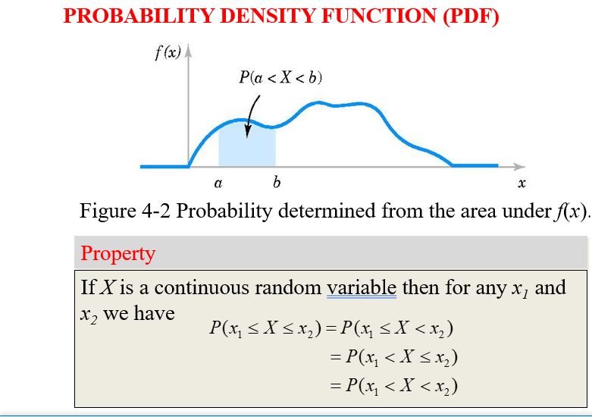

Cumulative distribution function (CDF): $F\left(a\right)=P\left(X≤a\right)$
$$F\left(a\right)=\int_{-∞}^{a}{f\left(x\right)dx}$$
$$P\left(X>a\right)=\int_{a}^{+∞}{f\left(x\right)dx}$$
$$P\left(a<x<b\right)=\int_{a}^{b}{f\left(x\right)dx}$$
Note: $P\left(X<a\right)=P\left(X≤a\right)$ tức là ta không quan tâm đến dấu bằng ở đầu mút
Mean $μ=E\left(X\right)=$
Variance $σ^{2}=E\left(X^{2}\right)-μ^{2}=$ or
$σ^{2}=E{\left(X-μ\right)}^{2}=$

Suppose that f (x) = e^{-x} for 0 < x. Determine the following
a. P(1 < X) b. P(1 < X < 2.5)
d. P(X < 4) e. m such that P(m < X) = 0.10

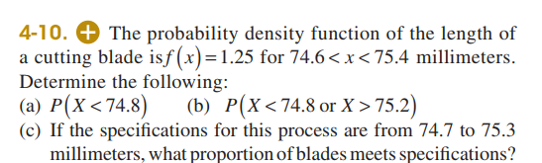

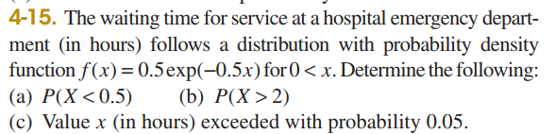

b) $P\left(X>2\right)=$

c)

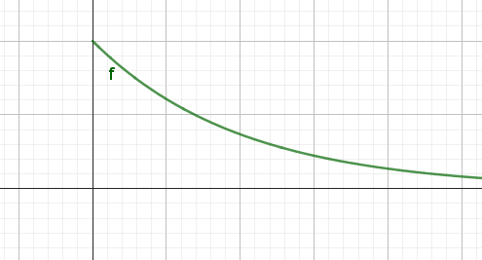

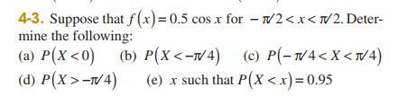

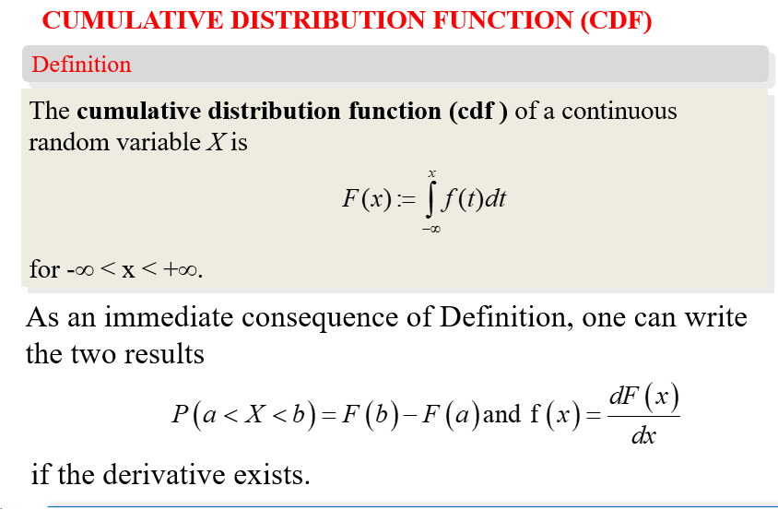

Ex: Let $f\left(x\right)=1.5x^{2}, -1<x<1$ be the PDF of a variable X.
Find F(x)=?
$$F\left(x\right)=P\left(X≤x\right)=\int_{-∞}^{x}{f\left(t\right)dt}$$

+ On $\left(-∞,-1\right], i.e. x≤-1→f\left(x\right)=0$
$$F\left(x\right)=\int_{-∞}^{x}{f\left(t\right)dt}=0$$
+ On $\left(-1,1\right), i.e. -1<x<1→f\left(x\right)=1.5x^{2}$
$$F\left(x\right)=\int_{-∞}^{x}{f\left(t\right)dt}=\int_{-∞}^{-1}{f\left(t\right)dt}+\int_{-1}^{x}{f\left(t\right)dt}$$
$$=\int_{-1}^{x}{1.5t^{2}dt}={\left.\frac{1.5t^{3}}{3}\right|}_{-1}^{x}=\frac{1}{2}\left(x^{3}+1\right)$$
+ On $\left[1,∞\right)$
$$F\left(x\right)=\int_{-∞}^{x}{f\left(t\right)dt}=\int_{-∞}^{-1}{f\left(t\right)dt}+\int_{-1}^{1}{f\left(t\right)dt}+\int_{1}^{x}{f\left(t\right)dt}=1$$

$$F\left(x\right)=\left\{\begin{aligned}0, if x≤-1 \\ \frac{x^{3}}{2}+\frac{1}{2}, if-1<x<1, \\ 1, if x≥1\end{aligned}\right.$$

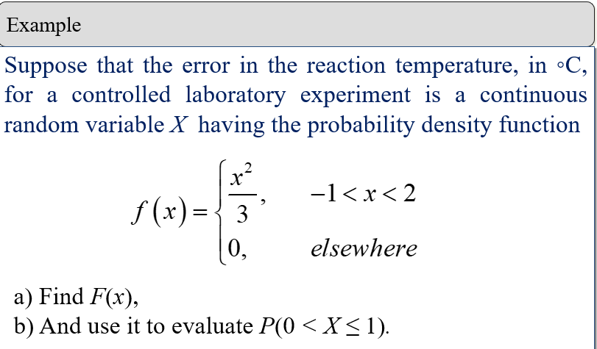

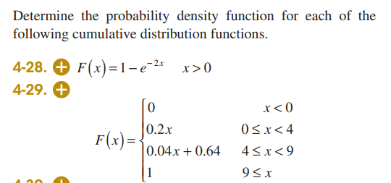

EX: Find m such that the following function is a density distribution function:
$$f\left(x\right)=mx^{2}, -2≤ x≤1$$
$f$ is a pdf $⇔\int_{-∞}^{∞}{f\left(x\right)dx}=1$
$$⇔\int_{-2}^{1}{mx^{2}dx}=1$$
$$⇔ {\left.\frac{mx^{3}}{3}\right|}_{-2}^{1}=1$$
$$⇔\frac{m}{3}+\frac{8m}{3}=1$$
$$⇔m=\frac{1}{3}$$

Suppose that the cumulative distribution function of
the random variable X is
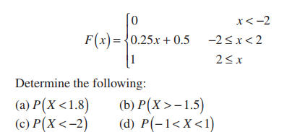

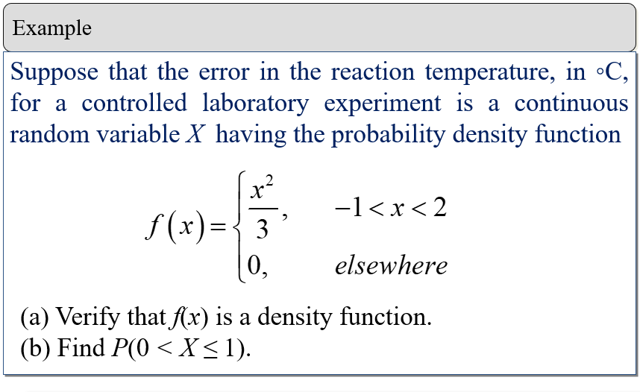
$f(x)$ is a density function if
$$\int_{-∞}^{∞}{f\left(x\right)dx}=1$$
$$\int_{-∞}^{∞}{f\left(x\right)dx}=\int_{-∞}^{-1}{f\left(x\right)dx}+\int_{-1}^{2}{f\left(x\right)dx}+\int_{2}^{∞}{f\left(x\right)dx}$$
$$=\int_{-∞}^{-1}{0dx}+\int_{-1}^{2}{\frac{x^{2}}{3}dx}+\int_{2}^{∞}{0dx}$$
Therefore,
$$\int_{-∞}^{∞}{f\left(x\right)dx}=\int_{-1}^{2}{\frac{x^{2}}{3}dx}=1$$
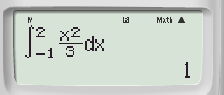
b)$P\left(0<X≤1\right)=\int_{0}^{1}{\frac{x^{2}}{3}dx}$
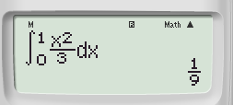
c) mean
$$E\left(X\right)=\int_{-∞}^{∞}{xf\left(x\right)dx}=\int_{-1}^{2}{x\frac{x^{2}}{3}dx}$$
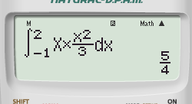
Variance
$$σ^{2}=Var\left(X\right)=\int_{-∞}^{+∞}{{\left(x-μ\right)}^{2}f\left(x\right)dx}=\int_{-1}^{2}{{\left(x-\frac{5}{4}\right)}^{2}*\frac{x^{2}}{3}dx }$$
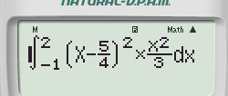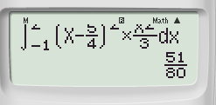

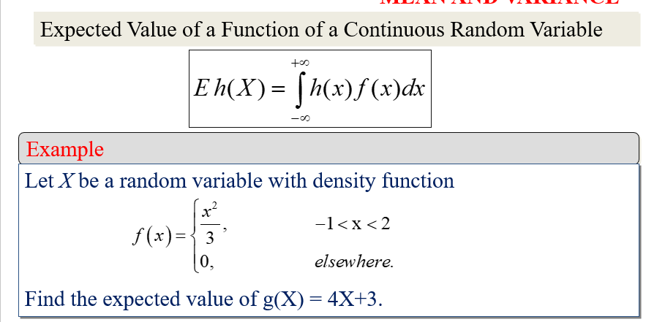
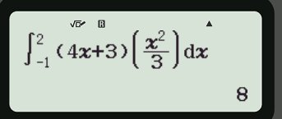

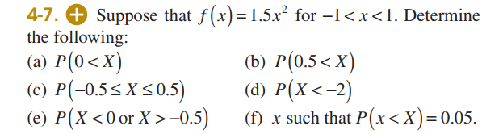
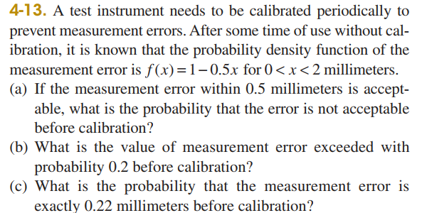
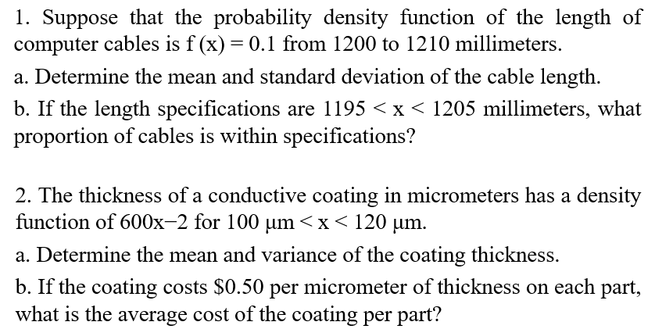

4.5. Continuous Uniform Distribution
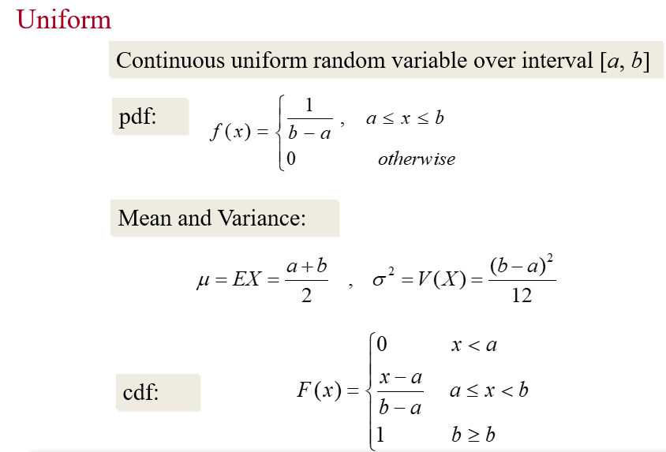

Example: The random variable X has a continuous uniform distribution on [4.9, 5.1]. The probability density function of X is
$f \left(x\right)=\frac{1}{5.1-4.9}=5, 4.9 ≤ x ≤ 5.1.$

What is the probability that a measurement of current is between 4.95 and 5.0 milliamperes?
$$P\left(4.95≤X≤5\right)=\int_{4.95}^{5}{5dx}$$
$$f\left(x\right)=5, 4.9 ≤ x ≤ 5.1.$$
$μ=E\left(X\right)=\int_{4.9}^{5.1}{x×5dx}=5$
$$σ^{2}=\int_{4.9}^{5.1}{x^{2}×5dx}-5^{2}$$

